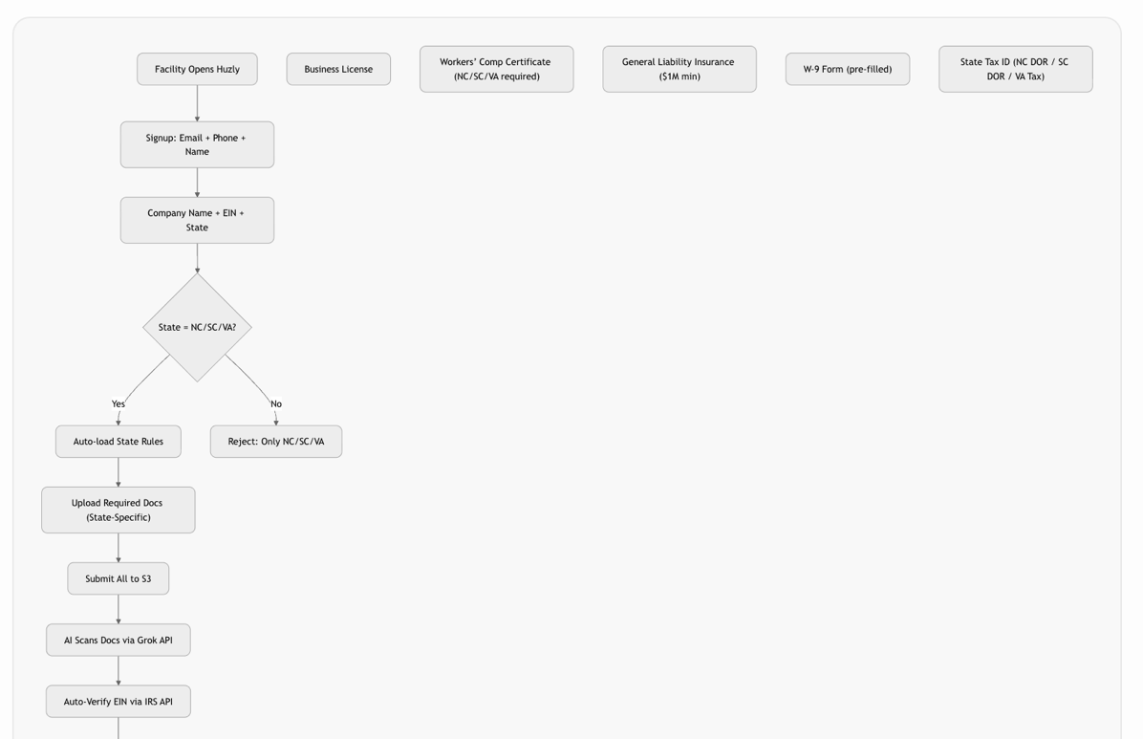


State-Specific Compliance Rules (Auto-Loaded)
State | Required Docs | Notes
NC | Workers’ Comp Certificate (even for 1099), NC Tax ID | NC DOI requires proof
SC | Workers’ Comp Exemption Form (if <4 employees), SC DOR ID | SC strict on comp
VA | Workers’ Comp Certificate, VA Tax ID | VA high fines for no comp
